**Ideal Employee Award**

**SRS- Part (1)**

Prepared For:

Eng. Mohammed Al-Safadi

Prepared By

Eng. Abdullah Arnous

Contents

Introduction 3

Purpose & Scope of the Project 3

Sprint Scope 3

Functional requirements 4

Users requirements 4

Employee requirements 4

Awards requirements 5

Rewards requirements 6

Application Form 7

User View 8

Use case Diagram 8

Class Diagram 9

Notes: 10

# Introduction

## Purpose & Scope of the Project

The document describes the first part of the Ideal Employee award functional requirements and scope of it. After all parts of the SRS is completed their will be a final document that describes the complete flow of the system. The system will be the place where the wanted employees can apply and be evaluated by working committees for ideal employee awards. The employee can apply through a website for the awards that can fit his/her requirements. There will be many awards depending on the position of the employee and different rewards for the 1st three ranks. It is useful to arrange some of the priorities that will be determined by the conditions and need for work in the deanship. Also, it will help to raise the level of each employee and it will make a perfect environment.

## Sprint Scope

The sprint will cover the landing page where the employee completes the registration, be verified by the direct boss and completes the application process for a specific award. Each award will be described through the registration and application process. The website will be in Arabic language only.

# Functional requirements

## Users requirements

* FR1: The employee is the only actor that should register through the website while others will have users that will be created at the database manually according to other privileges.

## Employee requirements

* FR2: The employee should register to apply for any awards.
* FR3: The employee should complete the form of registration to apply for any awards; the registration form will contain fields about the employee like position, direct boss, phone number, university email address, name, employee id etc.
  + The positions available to choose in a list will be the same positions that are allowed to apply for awards.
* FR4: After registration, an email be sent to the direct boss with the registered data of the employee to verify everything is alright.
  + If the direct boss chooses to not verify the employee due to wrong information; the employee will receive that his/her registration is unsuccessful
  + If the direct boss chooses to verify the employee; the employee will receive that his/her registration is successful
* FR5: The employee can apply for nondisabled award; the disabled awards will be open for other positions apart from the logging in employee position.
* FR6: The employee should be logged in to apply for the available and nondisabled award.
* FR7: To apply for an award, logged in employee should complete the application form for it.

## Awards requirements

* FR8: The award types will be five and below each one of them will be mentioned the positions that can apply:
  1. **Leadership employee award** will be available for:
* Director of Department
* Center Supervisor
* Unit Supervisor
* Agent Assistants
* Who are responsible of Computer center and development skills for training, external supervision unit in the female students residence, women’s sport club, Undersecretary Coordinator at the Center for University Studies in Alisha
  1. **Administrative Officer Award** will be available for:
     + Among the incumbents of administrative positions.
  2. **Technical Employee Award** will be available for:
     + Among the incumbents of technical positions like (Design, printing, maintenance, copying, programming) etc.
  3. **Field Officer Award** will be available for:
     + Among the incumbents of field supervision positions like (Housing Supervisor, Nutrition Supervisor, Sports Supervisor, Activity Supervisor) etc.
  4. **Support Employee Award** will be available for:
     + Among the incumbents of Support Services

## Rewards requirements

FR9: The reward for each 1st three ranks for each Award type:

* + - 1st rank reward:
      * 5000 SAR and Award shield for **Leadership employee award**
      * 4000 SAR and Award shield for **Administrative Officer Award**
      * 4000 SAR and Award shield for **Technical Employee Award**
      * 4000 SAR and Award shield for **Field Officer Award**
      * 3000 SAR and Award shield for **Support Employee Award**
    - 2nd and 3rd rank reward:
      * 2000 SAR for **Leadership employee award**
      * 2000 SAR for **Administrative Officer Award**
      * 2000 SAR for **Technical Employee Award**
      * 2000 SAR for **Field Officer Award**
      * 2000 SAR for **Support Employee Award**
    - General reward for all winners that will be written only in the description of the awards:
      * Job Excellence Certificates
      * Granting priority in obtaining domestic and international courses
      * Priority in mandate, or assignment of tasks, and the corresponding rest allowance; So that it does not exceed the upper limit allowed by the system.

# Application Form

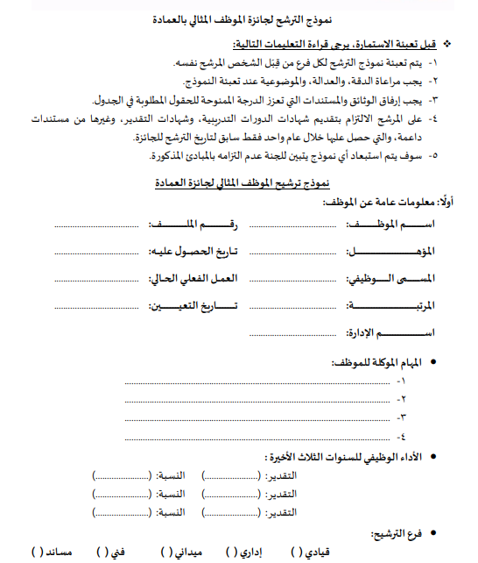

# User View

For this view, a use case diagram was done to clarify and visualize in the sprint how the actors of the system will interact and perform their actions in the system.

## Use case Diagram

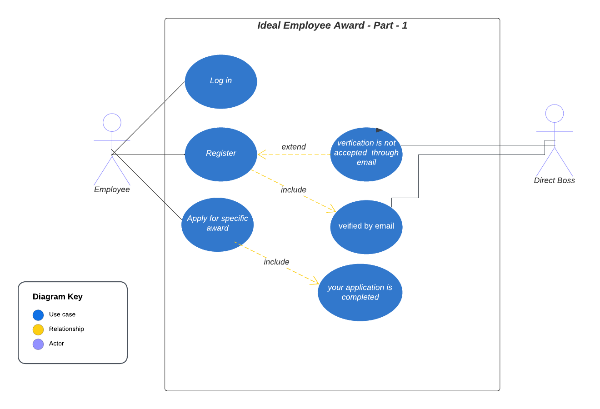

# Class Diagram

Class diagram will be used to represent the logical view

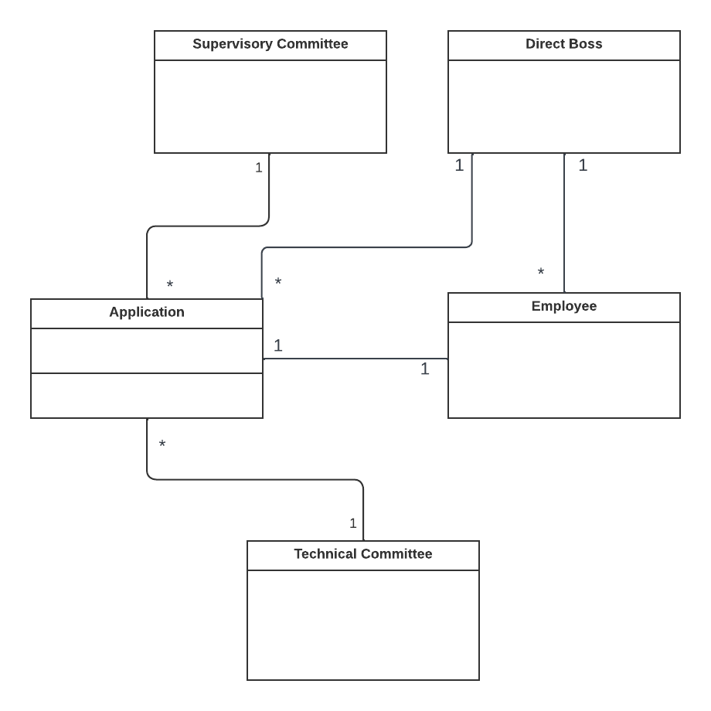

# Notes:

Here are some notes that should be answered by the client:

* Table B in the proposal form is required to be completed by whom?
* On page 3 in the proposal form, the second heading part, we should get all the information needed for making this requirement work. There is another solution, the direct boss is the one who is charged to verify the registration so, he/she can check the university system to make sure that the employee meets all the requirements mentioned at the second heading of 3 at the proposal form.